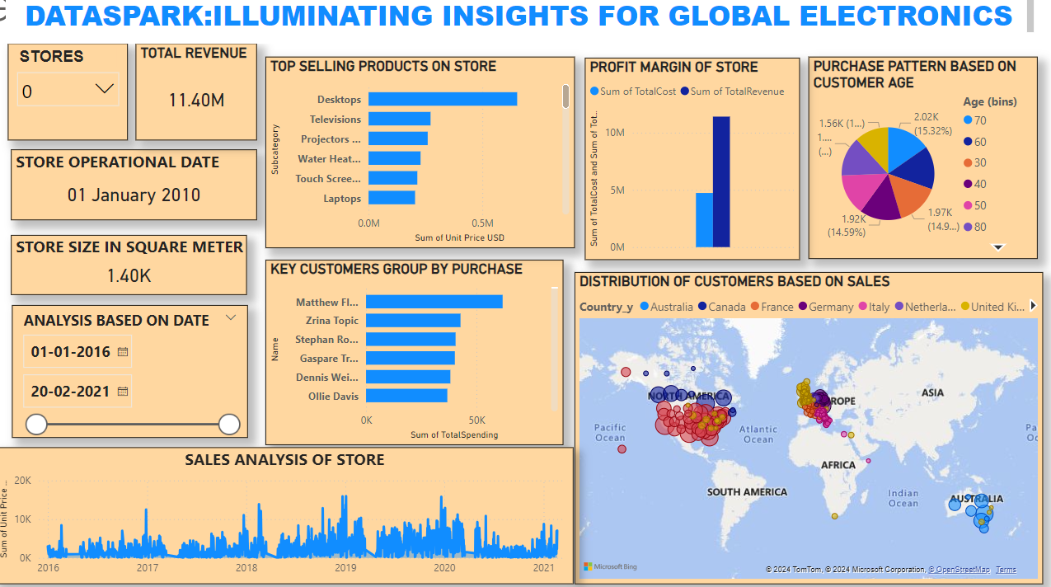

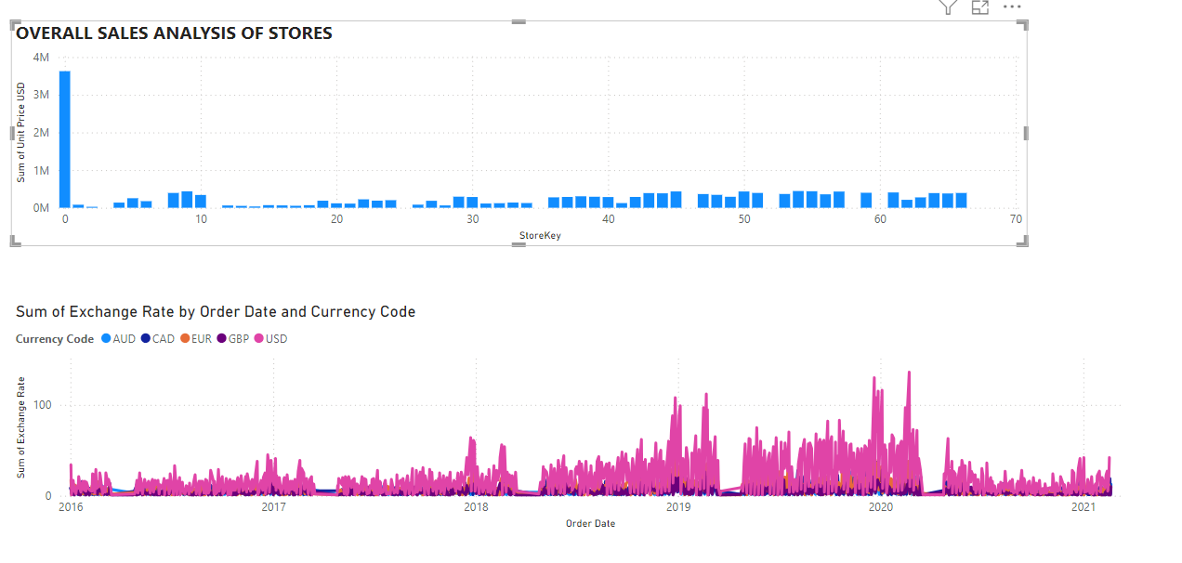

Here are effective recommendations based on the analysis:

Targeted Marketing Campaigns: Focus marketing efforts on key customer segments identified in the segmentation analysis. Tailor campaigns to the demographics and purchase patterns of these groups to enhance engagement and conversion rates.

Optimize Product Assortment: Increase inventory of high-performing products and consider phasing out or discounting less popular items to better align with customer preferences and improve sales efficiency.

Dynamic Pricing Strategies: Implement dynamic pricing based on sales trends and seasonality to maximize revenue. Adjust prices for top-performing products during peak seasons to capitalize on high demand.

Expand in High-Performing Regions: Use geographical analysis to identify regions with strong sales performance and consider expanding or opening new stores in these high-performing areas to increase market share.

Improve Store Layout and Operations: Evaluate and optimize store layouts and operations based on performance data. Consider changes that could enhance the shopping experience and increase sales per square meter.

Leverage Customer Purchase Patterns: Use insights from purchasing patterns to develop loyalty programs or personalized promotions that encourage repeat purchases and increase average order value.

Enhance Online Presence: If certain currencies or regions are showing high sales, consider improving online marketing and sales channels in those areas to capture more market potential.

Adjust Inventory by Currency: Monitor sales performance by currency and adjust inventory levels and pricing strategies to mitigate the impact of exchange rate fluctuations and optimize profitability.

Diversify Product Categories: Based on category analysis, explore opportunities to introduce new product categories or expand existing ones that show strong sales potential or high profit margins.

Benchmark Store Performance: Regularly compare store performance metrics and implement best practices from top-performing stores across all locations to drive improvements and consistency in operations.